http://www.html-5-tutorial.com/:
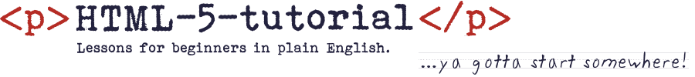
- home
- start tutorial
- what is HTML?
- what is HTML5?
- what it's not
- <doctype>
- <html>
- <head>
- <body>
- <h1> - <h6>
- <p>
- <ul> & <ol>
- <dl>
- <a>
- <table>
- <strong> & <b>
- <div>
- <div> cont.
- <header>
- <nav>
- <article>
- <footer>
- <aside>
- <section>
- <img>
- <img> cont.
- <map> & <area>
- <form>
- <input>
- get a domain NEW
- get a server NEW
- signing up NEW
- blog
- all HTML5 tags
- helpful links
- glossary
- contact
start HTML5 tutorial

HTML5 – A tutorial for beginners

It's not rocket science.
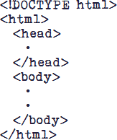
To the uninitiated HTML5 might look like rocket science, but it's not. Believe me, if you passed high school algebra you can figure this out.
My goal on html-5-tutorial.com is to give you a good solid start on doing just that.
When you have completed this tutorial you'll have a basic understanding of HTML and know how to go about getting a domain and building a simple website.
You won't be ready to quit your day job, but...
...you have to start somewhere!
HTML-5-Tutorial.com is geared to those who want to edit and write HTML code by hand. Knowing how the nuts and bolts of a webpage fit and work together gives you the means to utilize HTML5's full potential. Debugging and tweaking the code is easier and it greatly facilitates search engine optimization (SEO).
So what is HTML5? HTML5 is a language – a language computers use to "speak" to each other. However, left to their own devices, computers are mute machines – we aren't, and in the words of the Great Bard...
"Therein lies the rub."
start HTML5 tutorial

HTML5
Hypertext Markup Language ver. 5
google · wikipedia · w3.org

HTML
Hypertext Markup Language – history
wikipedia
Note: Technical terms in red are defined at the bottom
of the page and in the glossary.

domain
A web address such as www.domain.com.
For example, the domain name for this web site is html-5-tutorial.com.
wikipedia

SEO
Search Engine Optimization – designing pages to rank high in search engine results.
wikipedia · google

HTML5 Tutorial | Tutorial HTML5
"May the line of least resistance lead me on." Delbert McClinton
This site is hosted with bluehost.
privacy policy | about html-5-tutorial.com | copyright

 | Bookmark html-5-tutorial.com  (In Chrome press Ctrl-D)
You may need to upgrade your browser to IE 9.0, Chrome or FireFox.
Older browsers, most notably IE 8.0 and earlier, do not support HTML5.
© 2017 Duncan Aitken • Barrio Jucanya, Panajachel, Guatemala C.A. • Atitlan Design • duncansprivateemail@gmail.com

